**Palm series**

Uniquely engineered to support advanced applications in the agricultural industry, the PALM line boosts the productivity and efficiency while enhancing the speed and safety of harvesting activities.

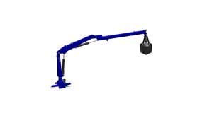

**8.370 Palm**

Max. Lifting capacity (kg)

260

Lifting Moment Class (tm)

4

Max. Extension reach (m)

3.85

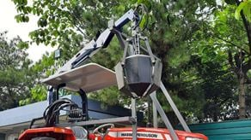

**801N PALM**

Max. Lifting capacity (kg)

125

Lifting Moment Class (tm)

1

Max. Extension reach (m)

2.8



**802N PALM**

Max. Lifting capacity (kg)

290

Lifting Moment Class (tm)

2

Max. Extension reach (m)

2.8